19.41: 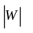 is the area under the path from A to B in the 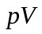-graph. The volume decreases, so W < 0.
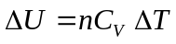
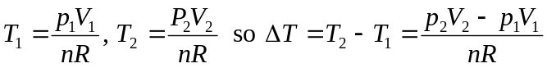
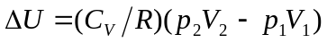
Then 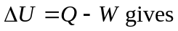
Q is negative, so heat flows out of the gas.

